Devin Hardy

00076619

CS423

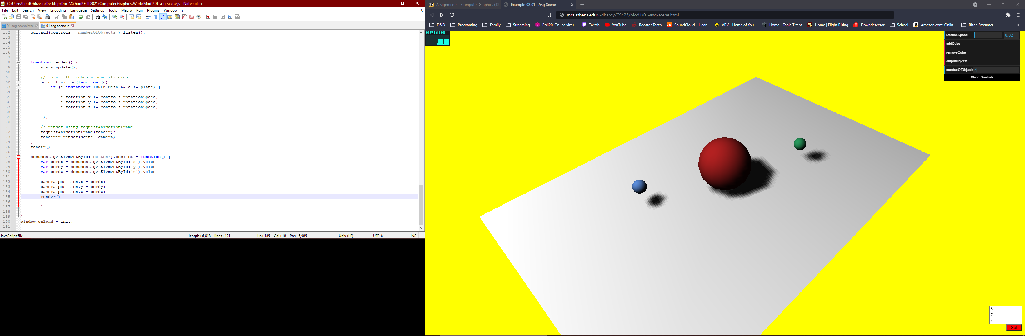

<!DOCTYPE html>

<HTML>

<HEAD>

<TITLE>Example 02.01 - Asg Scene</TITLE>

<SCRIPT TYPE="text/javascript" SRC="../libs/three.js"></SCRIPT>

<SCRIPT TYPE="text/javascript" SRC="../libs/stats.min.js"></SCRIPT>

<SCRIPT type="text/javascript" src="../libs/dat.gui.min.js"></SCRIPT>

<style>

body {

/\* set margin to 0 and overflow to hidden, to go fullscreen \*/

margin: 0;

overflow: hidden;

}

</style>

<!-- Attempt at adding a imput box positioning-->

<style>

.poz

{

position:absolute;bottom:35px; right:10px; width:5%;

}

.boz

{

position:absolute;bottom:55px; right:10px; width:5%;

}

.doz

{

position:absolute;bottom:75px; right:10px; width:5%;

}

button

{

background-color: red;

position:absolute;bottom:15px; right:10px; width:50px;

}

</style>

</head>

<body>

<div id="Stats-output">

</div>

<!-- Area to input NO clue what else to do -->

<!-- Div which will hold the Output -->

<Div id="WebGL-output">

</Div>

<!-- Javascript code that runs our three.js examples -->

<script type="text/javascript" src="01-asg-scene.js">

</script>

<form>

<input id = "x" type="number" step="0.01" class="doz"> <!-- For x -->

<input id = "y" type="number" step="0.01" class="boz"> <!-- For y -->

<input id = "z" type="number" step="0.01" class="poz"> <!-- For z -->

<button id="button">

Set

</button>

</form>

</body>

</HTML>

//

// File: 01-asg-scene.js

// Demo some of the basics of working with the scenegraph

// This is an extension of code from he Learning THREE.js textbook

// once everything is loaded. we run our Three.js stuff

var camera

function init() {

var stats = initStats();

function initStats() {

var stats = new Stats();

stats.setMode(0); // 0: fps, 1: ms

//Align top-left

stats.domElement.style.position = 'absolute';

stats.domElement.style.left = '0px';

stats.domElement.style.top = '0px';

document.getElementById("Stats-output").appendChild(stats.domElement);

return stats;

}

// create a scene, that will hold all our elements such as objects, cameras and lights.

var scene = new THREE.Scene();

// create a camera, which defines where we're looking at.

camera = new THREE.PerspectiveCamera(45, window.innerWidth / window.innerHeight, 0.1, 1000);

scene.add(camera);

// create a render and set the size

var renderer = new THREE.WebGLRenderer();

renderer.setClearColor(new THREE.Color(0xEEEEEE, 1.0));

renderer.setSize(window.innerWidth, window.innerHeight);

renderer.shadowMapEnabled = true;

// create the ground plane

var planeGeometry = new THREE.PlaneGeometry(60, 40, 1, 1);

var planeMaterial = new THREE.MeshLambertMaterial({color: 0xffffff});

var plane = new THREE.Mesh(planeGeometry, planeMaterial);

plane.receiveShadow = true;

// rotate and position the plane

plane.rotation.x = -0.5 \* Math.PI;

plane.position.x = 0;

plane.position.y = 0;

plane.position.z = 0;

// add the plane to the scene

scene.add(plane);

// position and point the camera to the center of the scene

camera.position.x = -30;

camera.position.y = 40;

camera.position.z = 30;

camera.lookAt(scene.position);

// add subtle ambient lighting

var ambientLight = new THREE.AmbientLight(0x0c0c0c);

scene.add(ambientLight);

// add spotlight for the shadows

var spotLight = new THREE.SpotLight(0xffffff);

spotLight.position.set(-40, 60, -10);

spotLight.castShadow = true;

scene.add(spotLight);

// add the output of the renderer to the html element

document.getElementById("WebGL-output").appendChild(renderer.domElement);

var controls = new function () {

this.rotationSpeed = 0.02;

this.numberOfObjects = scene.children.length;

this.removeCube = function () {

var allChildren = scene.children;

var lastObject = allChildren[allChildren.length - 1];

if (lastObject instanceof THREE.Mesh) {

scene.remove(lastObject);

this.numberOfObjects = scene.children.length;

}

};

this.addCube = function () {

var cubeSize = Math.ceil((Math.random() \* 3));

var cubeGeometry = new THREE.BoxGeometry(cubeSize, cubeSize, cubeSize);

var cubeMaterial = new THREE.MeshLambertMaterial({color: Math.random() \* 0xffffff});

var cube = new THREE.Mesh(cubeGeometry, cubeMaterial);

cube.castShadow = true;

cube.name = "cube-" + scene.children.length;

// position the cube randomly in the scene

cube.position.x = -30 + Math.round((Math.random() \* planeGeometry.parameters.width));

cube.position.y = Math.round((Math.random() \* 5));

cube.position.z = -20 + Math.round((Math.random() \* planeGeometry.parameters.height));

// add the cube to the scene

scene.add(cube);

this.numberOfObjects = scene.children.length;

};

this.outputObjects = function () {

console.log(scene.children);

}

};

//Placing other objects

// Add a Large sphere

var sphereGeometry = new THREE.SphereGeometry(4, 20, 20);

var sphereMaterial = new THREE.MeshLambertMaterial({color: 0xAC2020, wireframe: false});

var sphere = new THREE.Mesh(sphereGeometry, sphereMaterial);

sphere.castShadow = true;

sphere.position.x = 0;

sphere.position.y = 4;

sphere.position.z = 0;

scene.add(sphere);

// Add a Small sphere 1

var sphereGeometry = new THREE.SphereGeometry(1, 20, 20);

var sphereMaterial = new THREE.MeshLambertMaterial({color: 0x27955A, wireframe: false});

var sphere = new THREE.Mesh(sphereGeometry, sphereMaterial);

sphere.castShadow = true;

sphere.position.x = 12;

sphere.position.y = 4;

sphere.position.z = 5;

scene.add(sphere);

// Add a Small sphere 2

var sphereGeometry = new THREE.SphereGeometry(1, 20, 20);

var sphereMaterial = new THREE.MeshLambertMaterial({color: 0x5787D2, wireframe: false});

var sphere = new THREE.Mesh(sphereGeometry, sphereMaterial);

sphere.castShadow = true;

sphere.position.x = -12;

sphere.position.y = 4;

sphere.position.z = -5;

scene.add(sphere);

//GUI

var gui = new dat.GUI();

gui.add(controls, 'rotationSpeed', 0, 0.5);

gui.add(controls, 'addCube');

gui.add(controls, 'removeCube');

gui.add(controls, 'outputObjects');

gui.add(controls, 'numberOfObjects').listen();

function render() {

stats.update();

// rotate the cubes around its axes

scene.traverse(function (e) {

if (e instanceof THREE.Mesh && e != plane) {

e.rotation.x += controls.rotationSpeed;

e.rotation.y += controls.rotationSpeed;

e.rotation.z += controls.rotationSpeed;

}

});

// render using requestAnimationFrame

requestAnimationFrame(render);

renderer.render(scene, camera);

}

render();

document.getElementById('button').onclick = function() {

var cordx = document.getElementById('x').value;

var cordy = document.getElementById('y').value;

var cordz = document.getElementById('z').value;

camera.position.x = cordx;

camera.position.y = cordy;

camera.position.z = cordz;

render();

}

}

window.onload = init;

Could not get the camera to reposition